CCDC Windows handbook
PHASE 0
Windows Systems in your diagram
- AD / DNS(Domain controller) → Windows Server 2019
- Web → Windows Server 2019
- FTP → Windows Server 2022
- Workstation → Windows 11

PHASE 1 - Immediate Account Security
1. Rotate ALL Passwords
CHANGE PASSWORDS FOR ALL ADMIN ACCOUNTS
On Domain Controller:
net user administrator *
Check for extra admins
net localgroup administrators
Remove anything suspicious.

2. Disable or Remove Unnecessary Accounts
On Domain Controller
Get-ADUser -Filter * | Select Name,Enabled
Disable anything not required:
Disable-ADAccount -Identity username

3. Enforce Strong Password Policy (Domain)
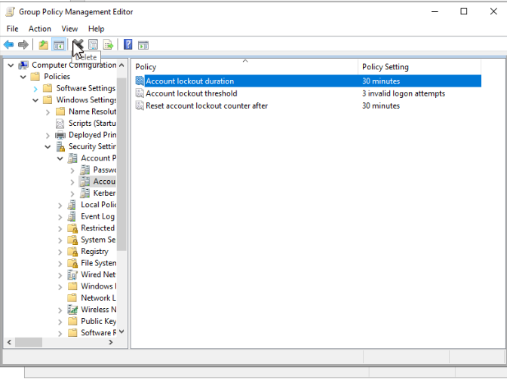
STEP 1 - Open Group Policy Management

STEP 2 - Edit the Default Domain Policy
Password policies must be set at the domain level.
In the left pane:
- Expand your Forest
- Expand Domains
- Click your domain name
- Right-click Default Domain Policy
- Click Edit

STEP 3 — Navigate to Password Policy
In the Group Policy Editor:
Computer Configuration
└─ Policies
└─ Windows Settings
└─ Security Settings
└─ Account Policies
└─ Password Policy

STEP 4 - Configure Password Settings Values
Set the following one by one:
Enforce password history
- Value: 24 passwords remembered
Prevents password reuse.

Maximum password age
- Value: 60 days
Forces periodic changes without annoying users too often.

Minimum password age
- Value: 1 day
Prevents rapid cycling to reuse an old password.

Minimum password length
- Value: 14 characters
This is a huge security boost and CCDC-friendly.

Password must meet complexity requirements
- Enabled
Requires:
- Uppercase
- Lowercase
- Number
- Special character

STEP 5 - Configure Account Lockout Policy
Navigate to:
Account Policies
└─ Account Lockout Policy
Set these values:
Account lockout threshold
- 5 invalid attempts

Account lockout duration
- 30 minutes

Reset account lockout counter after
- 30 minutes
This prevents brute-force attacks.

STEP 6 -Apply & Close
- Close the Group Policy Editor
- Policy saves automatically

STEP 7 - Force the Policy to Apply
On the Domain Controller:
gpupdate /force

STEP 8 - Force Users to Change Passwords
To force all users to change passwords at next login:
Run ForcePassChange Script
PHASE 2 - Lock Down Remote Access (EACH WINDOWS MACHINE)
Disable RDP via System Settings
On the machine you want to lock down:
- Press Win + R or search run
- Type:
- SystemPropertiesRemote
- Under Remote Desktop:
  - Select Don’t allow remote connections to this computer
- Click Apply → OK

PHASE 3 — Firewall Hardening (ALL WINDOWS MACHINE)
7. Enable Windows Firewall
Set-NetFirewallProfile -Profile Domain,Public,Private -Enabled True

8. Allow Only Required Ports
Each windows machine has a designated script in the repo. Run the designated script as admin on the machine
Block SMB From Workstation
Workstations should not host SMB
Disable-WindowsOptionalFeature -Online -FeatureName SMB1Protocol

PHASE 4 - Patch
9. Windows Updates
Install-Module PSWindowsUpdate
Get-WindowsUpdate
Install-WindowsUpdate -AcceptAll -AutoReboot
Reboot when needed.

PHASE 5 - Services Hardening(Every MACHINE)
10. Disable Unnecessary Services
On every machine:
services.msc
Disable if unused:
- Print Spooler
- Remote Registry
- Bluetooth
- SNMP
PHASE 6 - Active Directory Hardening (DOMIAN CONTROLLER)
11. Secure Domain Admins
Only 2 users
Domain Admins
Enterprise Admins
Check:
Get-ADGroupMember "Domain Admins"

12. Disable NTLM
Group Policy:
Computer Configuration →
Windows Settings →
Security Settings →
Local Policies →
Security Options
Set:
- Network security: Restrict NTLM → Deny All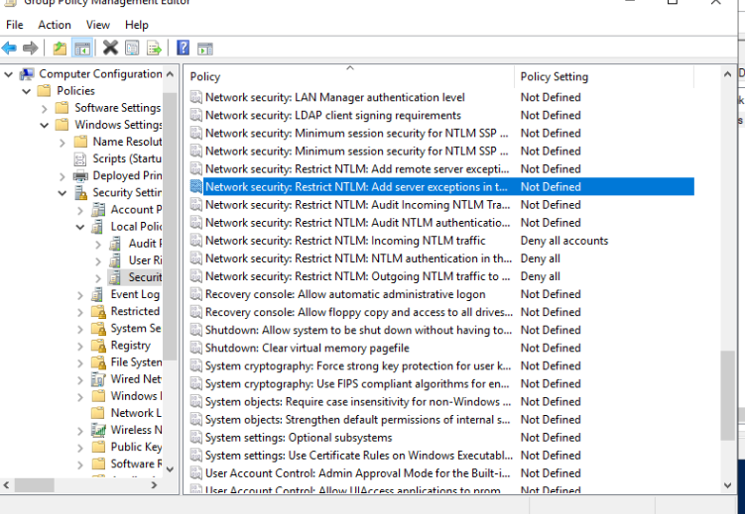

13. Disable Anonymous Enumeration
Network access: Do not allow anonymous enumeration of SAM accounts
Enabled

PHASE 7 - Logging & Detection (Domain controller)
14. Enable Advanced Auditing(DOMAIN)
On the Domain Controller:
- Open Group Policy Management: gpmc.msc
- Edit Default Domain Policy
- Go to:
Computer Configuration
→ Policies
→ Windows Settings
→ Security Settings
→ Advanced Audit Policy Configuration
→ Audit Policies
Enable these categories
Account Logon
- Audit Credential Validation (Success, Failure)
Logon/Logoff
- Audit Logon (Success, Failure)
- Audit Logoff (Success)
- Audit Special Logon (Success)
Account Management
- Audit User Account Management (Success, Failure)
- Audit Security Group Management (Success)
Privilege Use
- Audit Sensitive Privilege Use (Success, Failure)
Policy Change
- Audit Audit Policy Change (Success)
- Audit Authentication Policy Change (Success)
System
- Audit Security System Extension (Success)
- Audit System Integrity (Success, Failure)
Detailed Tracking (big win)
- Audit Process Creation (Success)

Turn on “Process Creation Command Line” logging
This makes Event ID 4688 include the actual command line (how you catch attacker PowerShell).
On each machine (or via GPO):
GPO path
Computer Configuration
→ Policies
→ Administrative Templates
→ System
→ Audit Process Creation
→ Include command line in process creation events = Enabled

Enable PowerShell Logging
GPO path
Computer Configuration
→ Policies
→ Administrative Templates
→ Windows Components
→ Windows PowerShell
Enable:
- Turn on Module Logging
Under Options, next to Module Names, click:
Show…
Add the module names
In the Show Contents window:
Under Value name, type: *

- Turn on PowerShell Script Block Logging
- Turn on PowerShell Transcription
C:\PSLogs\

Apply policy:
gpupdate /force

15. Increase Log Sizes(Every Box)
- PowerShell
- wevtutil sl Security /ms:524288000
- wevtutil sl System /ms:209715200
- wevtutil sl Application /ms:209715200
- 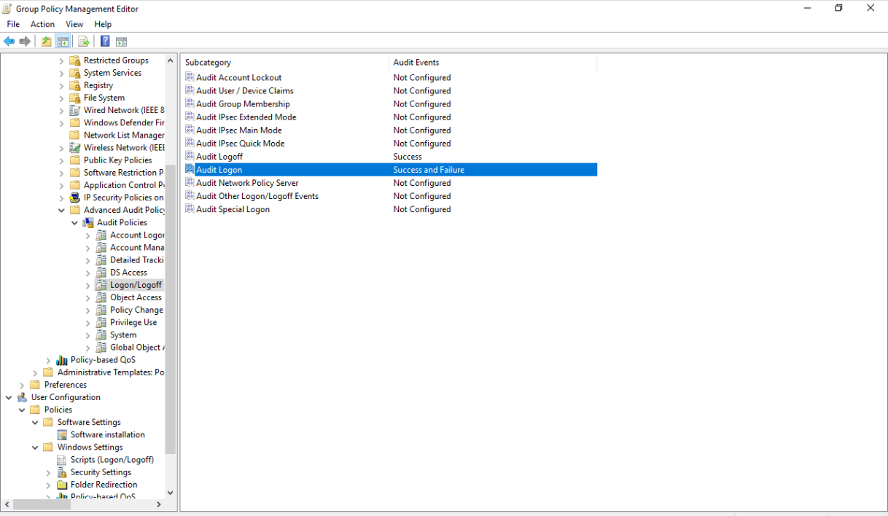

16. Install Sysmon(ALL MACHINES) IMPLEMENTATION WIP
Download Sysmon from browser
Sysmon64.exe -accepteula -i sysmonconfig.xml
This gives:
- Process tracking
- Network connections
- Persistence detection

PHASE 8 — Malware Protection (ALL MACHINES)
17. Microsoft Defender Hardening
Set-MpPreference -DisableRealtimeMonitoring $false
Set-MpPreference -EnableControlledFolderAccess Enabled
Set-MpPreference -PUAProtection Enabled
Run scan:
Start-MpScan -ScanType FullScan

PHASE 9 — Application Hardening
18. Web Server Hardening
Steps
- Open IIS Manager (inetmgr)
- Expand Sites
- Click Default Web Site
- Open Content View

Disable Directory Browsing
Directory browsing leaks files and configs.
Steps
- In IIS Manager
- Select your website
- Open Directory Browsing
- Click Disable
Verify:
- Browsing to / does NOT show file lists

Remove Unused IIS Modules (Attack Surface)
Steps
- Select the server name in IIS
- Open Modules
- Remove anything not required, such as:
  - WebDAV (VERY dangerous if unused)

Lock Down Application Pool Identity
Steps
- Open Application Pools
- Select your app pool
- Click Advanced Settings
- Set:
  - Identity → ApplicationPoolIdentity
Do NOT run as:
- LocalSystem
- Administrator
- Domain Admin
This prevents full system compromise via web exploit.

Disable HTTP Methods You Don’t Need
Attackers abuse PUT, DELETE, OPTIONS.
Steps
- Select the website
- Open Request Filtering
- Go to HTTP Verbs
- Allow only:
  - GET
  - POST
Remove:
- PUT
- DELETE
- TRACE

Lock File Permissions on Web Root
STEP 1 - Find the physical web root folder
In IIS Manager (same screen):
- Click Default Web Site
- On the right, click Basic Settings…
- Note the Physical path
It will almost certainly be:
C:\inetpub\wwwroot
That is the folder we will lock down.

STEP 2 - Open NTFS permissions on the web root
- Open File Explorer
- Navigate to the web root folder (e.g. C:\inetpub\wwwroot)
- Right-click the folder → Properties
- Go to the Security tab
- Click Advanced

STEP 3 — Disable inheritance (CRITICAL STEP)
At the top of Advanced Security Settings:
- Click Disable inheritance
- Choose:
Convert inherited permissions into explicit permissions
Do NOT choose “Remove all inherited permissions”
This preserves working permissions while letting us trim them safely.

STEP 4 -Remove dangerous permission entries
In the permissions list, remove these if present:
Everyone
Users (if they have Write / Modify)
Authenticated Users (if they have Write / Modify)
To remove:
- Click the entry
- Click Remove

STEP 5 - Set the CORRECT final permissions
Your final permissions should look like this:
SYSTEM
- Full control
Administrators
- Full control
IIS_IUSRS
- Read & execute
- List folder contents
- Read
NO Write
NO Modify

Application Pool Identity
Your site is using an Application Pool.
To be explicit and safe:
- In IIS Manager:
  - Click Application Pools
  - Find the pool used by Default Web Site
  - (Usually DefaultAppPool)
- Go back to folder permissions
- Click Add
- Principal:
- IIS AppPool\DefaultAppPool
- Set location to WEBSERVER2019
- Permissions:
  - Read & execute
  - List folder contents
  - Read

STEP 6 - Apply permissions
Click:
- Apply
- OK
- OK
In IIS Manager:
- Click Default Web Site
- Double-click Authentication
- Select Anonymous Authentication
- In the right pane, click Edit…
- Set Identity to:
Application pool identity
- Click OK
Now restart IIS:
Iisreset

IIS RAID PREVENTION
STEP 1 - REMOVE WEB DAV
Open IIS Manager → Modules
If you see:
WebDAVModule
Remove it.
PowerShell:
Remove-WebGlobalModule -Name WebDAVModule
Also remove feature:
Remove-WindowsFeature Web-DAV-Publishing

STEP 2 - LOCK FILE EXTENSIONS
In IIS:
Site → Request Filtering → File Name Extensions
Add Deny rules:
.config
.ps1
.cmd
.bat
.exe
.dll
.cs
.vbs
.js
PowerShell:
Add-WebConfigurationProperty `
-Filter /system.webServer/security/requestFiltering/fileExtensions `
-Name "." `
-Value @{fileExtension=".ps1";allowed="false"}
Repeat for dangerous types.

STEP 3 - DISABLE SCRIPT EXECUTION IN UPLOAD DIRECTORIES
If site has uploads like:
/uploads
/images
/files
Create web.config inside that folder:
<configuration>
<system.webServer>
<handlers accessPolicy="Read" />
</system.webServer>
</configuration>

STEP 4 - ENABLE REQUEST FILTERING PROTECTION
In IIS:
Request Filtering → URL → Deny Double Escaping = TRUE
PowerShell:
Set-WebConfigurationProperty `
-pspath 'MACHINE/WEBROOT/APPHOST' `
-filter "system.webServer/security/requestFiltering" `
-name "allowDoubleEscaping" `
-value "False"
This kills many traversal attacks.

STEP 5 - REMOVE UNUSED HANDLERS
In IIS:
Handler Mappings
Remove anything you don’t need:
*.cgi
*.exe
*.cmd
*.php
*.pl

STEP 6 - ENABLE FAILED REQUEST TRACING
This lets you see attacks instantly.
IIS → Site → Failed Request Tracing → Enable
Add rule:
Status Code: 400-999
Logs appear here:
C:\inetpub\logs\FailedReqLogFiles
You’ll literally see the exploit attempts.

STEP 9 -nVERY STRONG EXTRA DEFENSE
Add URL filtering for suspicious patterns:
IIS → Request Filtering → URL → Deny sequences:
..
%2e
%5c
cmd=
powershell

HOW TO KNOW IF WE GET HIT
Watch for these IIS logs:
POST /upload.aspx
PROPFIND
OPTIONS
PUT /shell.aspx
Also check Event ID:
4688 → w3wp.exe spawning powershell.exe
----------------------------------------------------------------------------------------------------------

FTP HARDENING (WINDOWS SERVER 2022) WIP
STEP 1 - Confirm FTP Is Actually Being Used
Before hardening, confirm FTP is required.
Check IIS
- Open IIS Manager (inetmgr)
- Expand Sites
- Look for an FTP Site
If no FTP site exists → stop here (FTP not in use).

STEP 2 - Disable Anonymous FTP
This is the #1 FTP vulnerability.
In IIS Manager:
- Click your FTP Site
- Double-click FTP Authentication
- Ensure:
  - Anonymous Authentication = Disabled
  - Basic Authentication = Enabled

STEP 3 — Lock Down FTP Authorization Rules
This controls who can log in and what they can do.
Steps:
- Open FTP Authorization Rules
- Remove any rule that says:
  - “All users”
  - “Anonymous users”
- Click Add Allow Rule
- Choose Specified users or a dedicated group (recommended)
Example:
FTPUsers
- Permissions:
  - Read
  - Write (ONLY if scoring requires uploads)
Click OK

STEP 4 — Create a Dedicated FTP Root Directory (CRITICAL)
NEVER use:
- C:\
- C:\inetpub
- C:\Windows
Recommended:
D:\FTPData
(or C:\FTPData if no D: drive)
Create it now if it doesn’t exist.

STEP 5 - NTFS Permissions on FTP Root (VERY IMPORTANT)
Right-click the FTP root → Properties → Security → Advanced
Final permissions should be:
Principal | Permissions
SYSTEM | Full control
Administrators | Full control
FTPUsers (or specific users) | Read / Write (only if needed)
IIS_IUSRS | Read & Execute
No Everyone
No Authenticated Users
No Modify for generic users unless uploads required
Apply to:
This folder, subfolders and files

STEP 6 - Restrict Users to Their Own FTP Directories
This prevents users from browsing the entire FTP tree.
In IIS Manager:
- Click your FTP Site
- Double-click FTP User Isolation
- Select:
- User name directory (disable global virtual directories)
Folder structure must be:
D:\FTPData\
└── username1
└── username2
Each folder:
- Owned by that user
- NTFS permissions scoped to that user
This is huge for containment.

STEP 7 -Lock FTP Passive Ports (You Already Started This)
FTP must use a limited passive range.
In IIS Manager:
- Click the server name
- Open FTP Firewall Support
- Set:
- Data Channel Port Range: 50000-50100
- Click Apply
Firewall:
Allow inbound TCP:
21
50000–50100
Do NOT leave wide dynamic ranges.

STEP 8 - Enforce FTP over TLS (FTPS) IF SCORING ALLOWS
Only do this if scoring supports FTPS.
In IIS Manager:
- Click FTP Site
- Open FTP SSL Settings
- Set:
  - SSL Certificate → select one
  - Control Channel → Require SSL
  - Data Channel → Require SSL
If unsure → leave SSL optional (don’t break scoring).

STEP 9 - Disable Dangerous FTP Commands
In FTP Request Filtering:
- Block:
  - APPE
  - SITE
  - EXEC
This prevents command abuse.

STEP 10 - Enable FTP Logging
In IIS Manager:
- Click FTP Site
- Open FTP Logging
- Enable logging
- Log:
  - Client IP
  - Username
  - Commands
  - Status codes
Logs default to:
C:\inetpub\logs\LogFiles
Review often.

PHASE 10 -Persistence & Backdoors Check
22. Startup & Scheduled Tasks
Get-ScheduledTask
Get-ItemProperty HKLM:\Software\Microsoft\Windows\CurrentVersion\Run
Remove anything suspicious.

PHASE 11- Logging Fun (All MACHINES)
RUN SCRIPT FIRST, IF DOES NOT WORK, BELOW ARE manual STEPS
Run LoggingFun.ps1
Verify by running
auditpol /get /subcategory:"Process Creation"
wevtutil gl "Microsoft-Windows-PowerShell/Operational"
Get-Content $env:SystemRoot\System32\LogFiles\Firewall\pfirewall.log -Tail 20

Manual STEPS DO IF SCRIPT DOESN’T WORK
Turn Windows Into an EDR-Lite
Run on each Windows machine:
auditpol /set /category:"Logon/Logoff" /success:enable /failure:enable
auditpol /set /category:"Account Logon" /success:enable /failure:enable
auditpol /set /category:"Account Management" /success:enable /failure:enable
auditpol /set /category:"Detailed Tracking" /success:enable /failure:enable
auditpol /set /subcategory:"Process Creation" /success:enable
auditpol /set /subcategory:"Security System Extension" /success:enable
Then enable command-line logging:
reg add "HKLM\Software\Microsoft\Windows\CurrentVersion\Policies\System\Audit" /v ProcessCreationIncludeCmdLine_Enabled /t REG_DWORD /d 1 /f
What this gives you
You start seeing:
- 4688 → Process creation

Enable PowerShell Script Block Logging
Enable:
reg add HKLM\SOFTWARE\Policies\Microsoft\Windows\PowerShell\ScriptBlockLogging /v EnableScriptBlockLogging /t REG_DWORD /d 1 /f
Now you get:
Event ID 4104
Which literally shows the commands attackers run.

Add IIS Failed Request Tracing
You said IIS RAID exploit hit you — this would have exposed it instantly.
Enable:
IIS Manager → Site → Failed Request Tracing
Add rule:
Status codes: 400–999
Logs go here:
C:\inetpub\logs\FailedReqLogFiles
Forward that folder into Splunk if allowed.

Build a “High-Signal Event ID List”
Instead of watching logs, watch ONLY the events that matter.
Intrusion Critical (alert instantly)
7045 New service installed
1102 Security log cleared
4720 New user created
4728/4732 Added to admin group
4698 Scheduled task created
Lateral Movement / Auth
4625 Failed logon
4624 Logon type 10 (RDP)
4672 Admin privileges assigned
4776 NTLM auth
Execution
4688 Process created
4104 PowerShell script block
If you monitor only these, noise drops by ~80%.

Turn On Windows Defender Logging
Even if Defender isn’t your main tool, its logs are amazing signals.
Forward this log:
Microsoft-Windows-Windows Defender/Operational
Watch for:
1116 Malware detected
1117 Remediated

Add Firewall Logging
Enable:
Set-NetFirewallProfile -LogAllowed True -LogBlocked True -LogFileName %systemroot%\system32\LogFiles\Firewall\pfirewall.log
Forward that file to Splunk.

Stage | Events
Initial access | IIS logs + 4104
Credential abuse | 4625,4776
Privilege escalation | 4672,4728
Persistence | 7045,4698
Cleanup | 1102

